Homework 3

**Due on June 5 (Tuesday) in class**

* **Conceptual Questions**

**Q1.**  **(35 Points)**

Rank the following in ascending order of Home welfare and justify your answers by discussing the welfare effect at Home in the following situations. If two items are equivalent, indicate that accordingly. Consider the markets to be perfectly competitive.

1. Tariff of t in a small country corresponding to the quantity of imports M
2. Quota with the same imports M in a small country with quota licenses distributed to Home firms and no rent seeking.
3. Quota of M in a small country with the quota licenses auctioned to Home firms.
4. Quota of M in a small country with the quota given to the exporting Foreign firms.
5. Quota of M in a small country with quota licenses distributed to rent-seeking Home firms.

**Q2. (35 Points)**

Consider a small country applying a tariff t to imports of a good like that represented in the figure below.

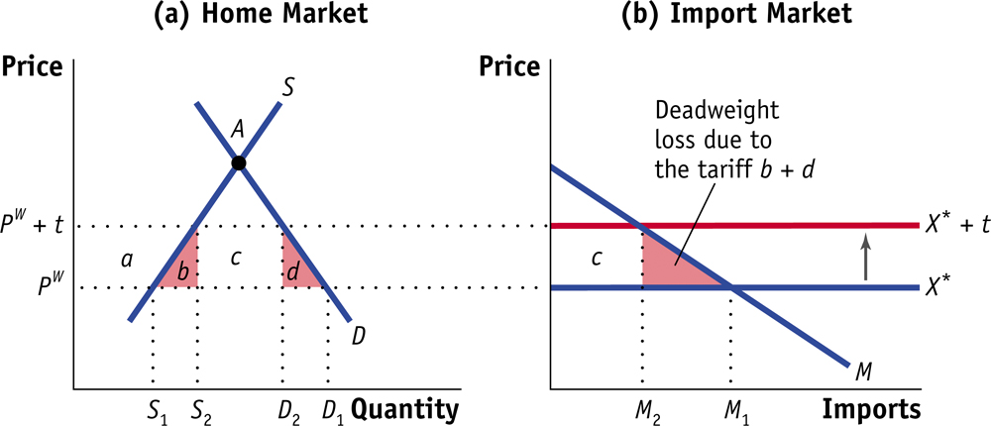

1. (10 Points) Suppose that the country decides to **reduce** its tariff from t to tNEW. Redraw the graphs for the Home and import (or world) markets and illustrate this change. What happens to the quantity and price of goods produced at Home? What happens to the quantity of imports?
2. (15 Points) Are there gains or losses to domestic consumer surplus due to the reduction in tariff? Are there gains or losses to the domestic producer surplus due to the reduction in tariff? How is the government revenue affected by the policy change? Illustrate these on your graphs.
3. (10 Points) What is the overall gain or loss in welfare due to the policy change?

* **Numerical Questions**

**Q3. (30 Points)**

Suppose the Home firm is considering whether to enter the Foreign market. Assume that the Home firm has the following costs and demand:

Fixed Costs = $140

Marginal Costs= $10 per unit

Local Price = $25

Local Quantity = 20

Export Price = $15

Export Quantity = 10

1. (5 points) Calculated the firm’s total costs from selling only in the local market.
2. (5 points) What is the firm’s average cost from selling only in the local market?
3. (5 points) Calculate the firm’s profit from selling only in the local market.
4. (5 points) Should the Home firm enter the Foreign market? Explain why.
5. (5 points) Calculate the firm’s profit from selling to both markets.
6. (5 points) Is the Home firm dumping? Explain.